# Deliverable 1

**Deliverable 1: Word Document** answering the following questions with SQL query and result (when submitting SQL queries, either paste the queries directly in your word document or upload your original script file):

I have created a notebook I pasted in my GitHub where you can see all the modifications I made before running the next queries. I take care of some missing values and data type formatting before getting into the questions.

1. **[SQL]** What is the average spending for a group of 2 people?

1. **[SQL]** What was the highest amount of Food purchased in a day and what was the date (please report on ArrivalDatetime in PDT)?

1. **[SQL]** What were the top 5 spending orders? The result should have 4 columns: OrderID, NumOfProducts, TotalRevenue, Rank. Sort by total revenue descending.

1. **[Data Visualization]** Based on the Food & Beverage dataset we provided, draft up a dashboard/report using a visualization tool that you are comfortable with (PowerBI, Tableau, etc.). Attach a screenshot and provide 3 insights you can get out of your report

I posted the dashboard in my public profile on Tableau where you can have access to the complete example.

In terms of the insights that I can get from my report:

First image:

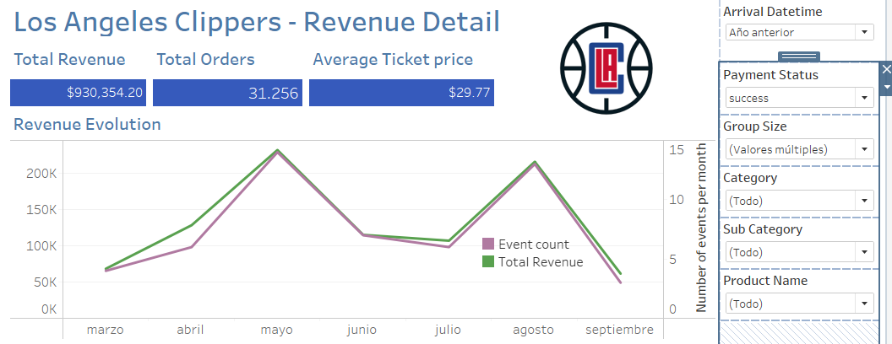

With this first image, I can come up with the first insight that is quite relevant although somehow cliche. Having half of the number of events translates into having half of the revenue driven by Food & Beverage per month. Therefore, we should try to have as many events as possible in Intuit Dome. For example, after Catlin Clark’s draft this last year, women’s Basketball, and particularly Indiana Fever, is experiencing a new phenomenon where stadiums are at full capacity to watch her playing. Hopefully, women's sports attendance keep increasing and one opportunity would be to consider creating a women's Basketball team to complement LA Clippers’ Seasonality (which is 0 over the summer). The marginal cost of having one more event is nothing compared to the loss in revenue that we experience if there are no events.

Second Image:

In the same part of the report, we can filter the data by failure in Payment Status. Even though the losses in revenue are 2.2% = 21.133 / (930.354 + 21.133) of the total possible revenue, we should pay attention to this number and keep it under control. An actionable here would be first to identify the source of failure and then to consider other types of payments to diminish this number and recover the losses in revenue.

Third image:

Fourth image:

After these two last images in the report, I come up with a second insight. First, I noticed that the Alcohol category is what drives half of our revenue while Food represents half of what Alcohol represents. On the other hand, in terms of quantity, water is the most sold product representing a third of the total quantities sold. Then, in the Fourth image, I created a filter to see the average ticket price of orders with and without water. Given that the price of water is cheaper than alcohol it makes sense that the Average Ticket Price is lower for orders with water. An actionable here would be to offer new bundles with water as the main product to incentivize the consumption of other products. For example, offer one water + one Modelo + one Hot Dog (7+20+9 in individual prices) for 32 USD to increase the average ticket price of orders with water and extract more revenue.

Note that we can do a similar analysis with the group size information that we can capture with the new technology:

